Country State of Environment Report Year

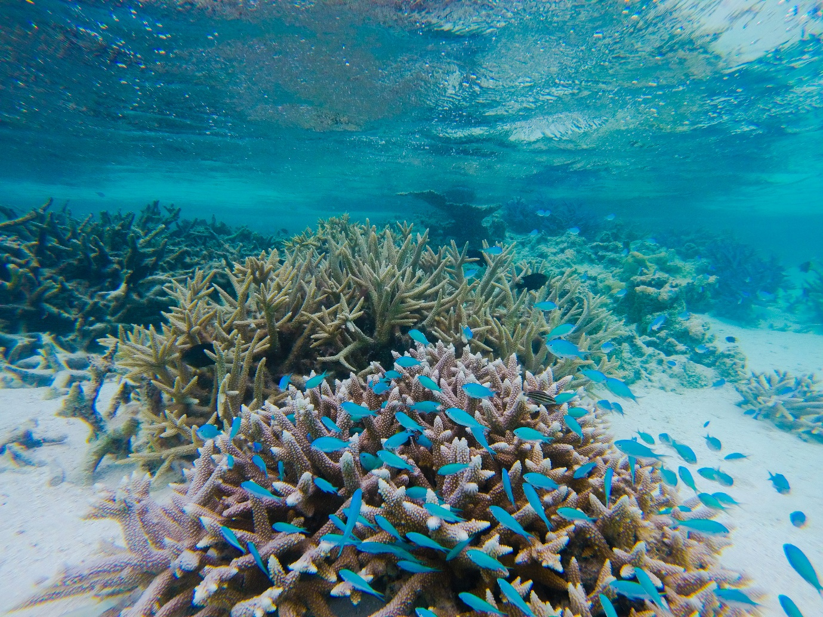
Please replace the photo below with one from the country (must be high resolution - ≥300ppi) and if possible, relevant to environmental issues included in the report. Please also credit the photographer and copyright.

Photo: © Peter McDonald

Contents
Acknowledgements 4
Acronyms 5
Message from the Minister/PM/Director of country 6
Message from Director of SPREP 7
EXECUTIVE SUMMARY 8
SECTION 1: INTRODUCTION AND READER’S GUIDE 13
Introduction and background 13
Readers guide to the year State of Environment Report 15
SECTION 2: DRIVERS AND PRESSURES ON THE COUNTRY ENVIRONMENT 20
Drivers for environmental change in COUNTRY 20
What environmental pressures are the drivers creating? 21
SECTION 3: STATE OF COUNTRY ENVIRONMENT, IMPACT AND RESPONSED 22
Theme 1: Atmosphere and climate 22
INDICATOR: GREENHOUSE GAS (GHG) EMISSIONS 23
INDICATOR: CONSUMPTION OF OZONE DEPLETING SUBSTANCES (ODS) 23
INDICATOR: RENEWABLE ENERGY 24
INDICATOR: CLIMATE-RELATED DEATHS 24
INDICATOR: CLIMATE-RELATED DEATHS 25
INDICATOR: CLIMATE-RELATED DISASTER LOSSES 26
INDICATOR: FUNDING FOR ECOYSTEM-BASED ADAPTATION 26
INDICATOR: CLIMATE ADAPTATION AND MITIGATON FUNDING 27
Theme 2: Island and Ocean Ecosystems 28
INDICATOR: TERRESTRIAL PROTECTED AREAS 28
INDICATOR: WETLANDS 29
INDICATOR: INVASIVE SPECIES UNDER MANAGEMENT OR ERADICATED 30
INDICATOR: PRIORITY SITES WITH INVASIVE SPECIES MANAGED 30
INDICATOR: IUCN RED LIST SUMMARY 31
INDICATOR: STATUS OF THREATENED, ENDEMIC AND MIGRATORY SPECIES 31
INDICATOR: FRESHWATER QUALITY 32
Theme 3: Built environment 33
INDICATOR: HOUSEHOLD WASTE CAPTURED 33
INDICATOR: PER CAPITA GENERATION OF MUNICIPAL SOLID WASTE 34
INDICATOR: HOUSEHOLD WASTE RECYCLED 34
INDICATOR: ACCESS TO AND QUALITY OF SEWAGE TREATMENT 35
Theme 4: Coastal and marine 36
INDICATOR: LIVE CORAL COVER 36
INDICATOR: LAGOON WATER QUALITY 37
INDICATOR: MARINE PROTECTED AREAS 37
INDICATOR: COMMERCIAL PELAGIC FISHES 38
INDICATOR: INSHORE FISH BIOMASS 39
Theme 5: Culture and heritage 40
INDICATOR: COUNTRY TO ADD THEIR OWN INDICATORS 40
Theme 6: Environmental governance 41
INDICATOR: ENVIRONMENT MINISTRY BUDGET ALLOCATION 41
INDICATOR: MEA REPORTING REQUIREMENTS 42
INDICATOR: APPROVED DEVELOPMENT PROPOSALS WITH CONDITIONS 42
INDICATOR: ENVIRONMENTAL CASES PROSECUTED 43
Theme 7: Land 44
INDICATOR: NATIVE TREE COVER 44
INDICATOR: LAND UNDER CULTIVATION 45

Acknowledgements

COORDINATION AND PLANNING
Insert names and affiliations
WRITING, ANALYSIS, DESIGN AND COMPILATION
Insert names and affiliations
KEY CONTRIBUTORS
Insert names and affiliations

Acronyms
Insert list of all acronyms in the SoE

Message from the Minister/PM/Director of country
Relevant official to write message. Include portrait photo.

Message from Director of SPREP
Message is updated for each country report.
Foreword
The natural environment has always been part of Pacific island cultures. It has shaped and influenced our way of life over the centuries and as the primary source providing for our Pacific communities, it has fed, clothed and kept us safe over the years.
Despite its immense value, our environment is under growing pressure due to economic development, tourism expansion and the threat of global climate change. Therefore, it is important that we continue monitoring and maintaining the quality of our environment for future generations.
The Year and Country State of Environment (SoE) Report updates the last report completed in year, if applicable. The report assesses seven themes as well as the baseline information for new and emerging environmental challenges.
This report places the emphasis on data-based conclusions and presents supporting evidence for all indicators.
The Year SoE Report is a new baseline for future reports and can help the country with national, regional and international reporting obligations, including multi-lateral environmental agreements. This report has already informed environmental planning and decision-making, and has guided the development of the National Environmental Management Strategy.
SPREP is pleased to have partnered with the country’s environmental department name in developing this document, as well as the many other agencies and civil society organisations that contributed to the consultative process.
I would like to sincerely thank the individuals and all the government ministries and departments for their contributions. It is important that regular updates to this SoE Report are conducted to assess country’s environmental conditions. I encourage you all to use this report to help track, manage, plan and report on natural resources and the environment.
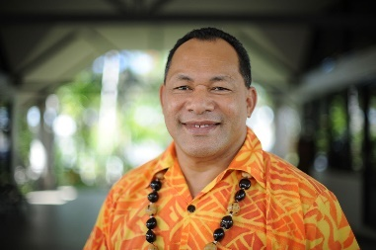
Kosi Latu
Director General
Secretariat of the Pacific Regional Environment Programme

EXECUTIVE SUMMARY
The Year State of Environment (SoE) Report for country updates Year SoE Report (if applicable), and uses the Drivers, Pressures, State, Impact and Response (DPSIR) model of reporting. The main aims of this report are to:
- Identify the key drivers and pressures behind the changing environment in country;
- Update the assessment of the country’s environment since the year SoE Report (if applicable) through use of the best available information for seven key thematic areas: Atmosphere and Climate, Inland Waters, Land, Marine, Biodiversity, Culture and Heritage, and Built Environment;
- Document the social, economic and environmental impacts that result from changes in the state of the environment;
- Document current responses by country to address changes in the state of the environment that better protect and manage resources; and
- Provide recommendations for country to address key challenges and build on existing strengths, which are linked to actions outlined by the National Environmental Strategy (NEMS).
ENVIRONMENTAL DRIVERS AND PRESSURES

Summary of information on drivers and pressures specific to country.

THE STATE OF COUNTRY’S ENVIRONMENT
Information was gathered from local stakeholders and experts on the seven themes to provide a summary of the state, impact and response. A summary is included at the beginning of each theme for a quick review. The following is a concise summary of each indicator in the SoE Report.

Theme: Atmosphere and Climate
Insert theme summary.
Theme: Biodiversity
Insert theme summary.
Theme: Built Environment
Insert theme summary.
Theme: Coastal and Marine
Insert theme summary.
Theme: Culture and Heritage
Insert theme summary.
Theme: Environmental Governance
Insert theme summary.
Theme: Land
Insert theme summary.

CONCLUSION AND OVERALL RECOMMENDATIONS
Information specific to country.
Table 1. Summary of themes and indicator from Country SoE 2019.
Theme | Indicators | Status and Trends | Response & Recommendations
ATMOSPHERE AND CLIMATE | Trend in Greenhouse Gas (GHG) emissions | Insert Status and Trend symbol | Insert key points from Response and Recommendations
ATMOSPHERE AND CLIMATE | Trend in consumption of ozone depleting substances (ODS) | Insert Status and Trend symbol | Insert key points from Response and Recommendations
ATMOSPHERE AND CLIMATE | Renewable energy | Insert Status and Trend symbol | Insert key points from Response and Recommendations
ATMOSPHERE AND CLIMATE | Climate-related deaths | Insert Status and Trend symbol | Insert key points from Response and Recommendations
ATMOSPHERE AND CLIMATE | Climate-related disaster losses | Insert Status and Trend symbol | Insert key points from Response and Recommendations
ATMOSPHERE AND CLIMATE | Funding for ecosystem management | Insert Status and Trend symbol | Insert key points from Response and Recommendations
ATMOSPHERE AND CLIMATE | Climate adaptation and mitigation funding | Insert Status and Trend symbol | Insert key points from Response and Recommendations
BIODIVERSITY | Wetlands | Insert Status and Trend symbol | Insert key points from Response and Recommendations
BIODIVERSITY | Wetlands | Insert Status and Trend symbol | Insert key points from Response and Recommendations
BIODIVERSITY | Terrestrial protected areas | Insert Status and Trend symbol | Insert key points from Response and Recommendations
BIODIVERSITY | Invasive species under management or eradicated | Insert Status and Trend symbol | Insert key points from Response and Recommendations
BIODIVERSITY | Priority sites with invasive species managed | Insert Status and Trend symbol | Insert key points from Response and Recommendations
BIODIVERSITY | IUCN red list summary | Insert Status and Trend symbol | Insert key points from Response and Recommendations
BIODIVERSITY | Status of threatened, endemic or migratory species | Insert Status and Trend symbol | Insert key points from Response and Recommendations
BIODIVERSITY | Freshwater quality | Insert Status and Trend symbol | Insert key points from Response and Recommendations
BUILT ENVIRONMENT | Household waste captured rate | Insert Status and Trend symbol | Insert key points from Response and Recommendations
BUILT ENVIRONMENT | Per capita generation of municipal solid waste | Insert Status and Trend symbol | Insert key points from Response and Recommendations
BUILT ENVIRONMENT | Household waste recycled | Insert Status and Trend symbol | Insert key points from Response and Recommendations
BUILT ENVIRONMENT | Access to and quality of sewage treatment | Insert Status and Trend symbol | Insert key points from Response and Recommendations
COASTAL AND MARINE | Live coral cover | Insert Status and Trend symbol | Insert key points from Response and Recommendations
COASTAL AND MARINE | Lagoon water quality | Insert Status and Trend symbol | Insert key points from Response and Recommendations
COASTAL AND MARINE | Marine protected areas | Insert Status and Trend symbol | Insert key points from Response and Recommendations
COASTAL AND MARINE | Commercial pelagic fishes | Insert Status and Trend symbol | Insert key points from Response and Recommendations
COASTAL AND MARINE | Inshore fish biomass | Insert Status and Trend symbol | Insert key points from Response and Recommendations
CULTURE AND HERITAGE | Country to select indicators | Insert Status and Trend symbol | Insert key points from Response and Recommendations
ENVIRONMENTAL GOVERNANCE | Environment Ministry budget allocation | Insert Status and Trend symbol | Insert key points from Response and Recommendations
ENVIRONMENTAL GOVERNANCE | MEA reporting requirements | Insert Status and Trend symbol | Insert key points from Response and Recommendations
ENVIRONMENTAL GOVERNANCE | Approved development proposals with conditions | Insert Status and Trend symbol | Insert key points from Response and Recommendations
ENVIRONMENTAL GOVERNANCE | Environmental cases prosecuted | Insert Status and Trend symbol | Insert key points from Response and Recommendations
LAND | Native tree cover | Insert Status and Trend symbol | Insert key points from Response and Recommendations
LAND | Land under cultivation | Insert Status and Trend symbol | Insert key points from Response and Recommendations

ENVIRONMENTAL DATA MANAGEMENT
Knowledge and understanding are important for driving and bringing about informed decision-making. The project, Building National and Regional Capacity to Implement Multilateral Enviro nmental Agreements by Strengthening Planning and the State of Environmental Assessment and Reporting in the Pacific, referred to as the Inform project, recognises the need for this data-driven decision-making. The project establishes a Pacific island network of national and regional data repositories and reporting tools to support the monitoring, evaluation, and analysis of environmental information, which supports environmental planning, forecasting, and reporting requirements.

From 2017–2021, Inform will work in the Cook Islands, Federated States of Micronesia, Fiji, Kiribati, Republic of the Marshall Islands, Nauru, Niue, Palau, Papua New Guinea, Samoa, Solomon Islands, Tonga, Tuvalu, and Vanuatu. The Global Environment Facility contributes 4.3 million USD to the Inform project, which is implemented by UN Environment and executed by SPREP.

Country now has an online and open source ‘Country Environmental Data Portal. The portal can be
accessed online via the following link: https://insert link. This portal can be a resource for uploading,
storing and sharing data in a central place, thus facilitating the process for compiling and analysing data when writing future SoE reports, NEMS and policies.

INSERT IMAGE OF NATIONAL PORTAL FRONT END

SECTION 1: INTRODUCTION AND READER’S GUIDE

Introduction and background
ENVIRONMENTAL REPORTING IN COUNTRY
Information specific to the country e.g. legislation mandating SoE.

THE YEAR AND YEAR SOE REPORTS – DIFFERENT APPROACHES OR APPROACH USED YEAR IN STATE OF ENVIRONMENT REPORT if this is the first
If relevant describe differences between current and previous SoE reports.
In line with the needs of the Solomon Islands Government and the regional support provided through SPREP and the Inform Project, the current report takes a different approach, by using the ‘Drivers, Pressures, State, Impact, Response’ (DPSIR) model.

The DPSIR model is an internationally accepted approach for reporting on the environment (Figure 2). Drivers are the factors that indirectly affect the environment. These drivers exert pressures that directly affect the environment, which may result in observable changes in trends or condition. The impacts of these changes will affect communities, economies and ecosystems. By understanding this system, informed responses can be applied to manage the various factors in this process. The links between the processes in the DPSIR model are not simple cause-and-effect relationships, but involve complex interactions, including cumulative and historical effects.
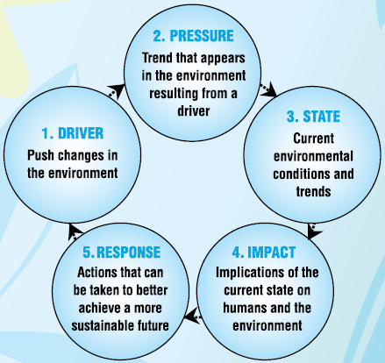

Figure 1. Drivers, Pressures, State, Impact and Response (DPSIR) model used for assessing the state of environment.
PURPOSE OF THE STATE OF ENVIRONMENT REPORT
The purpose of the country SoE Report is to present the best available information about the current state of the environment as the basis for effective environmental management and planning (The SoE Report examines the major drivers of change to the environment that emerge from global, regional and national factors. The SoE Report evaluates the main environmental pressures created by these drivers, and examines their social, economic and environmental impacts.
State of Environment (SoE) reporting is an internationally accepted reporting method that analyses the condition of a geographic area or jurisdiction’s ecosystems, and associated natural resources. SoE Reports compile and analyse quantitative and qualitative data from a variety of local, national, regional, and international sources to provide a holistic picture of a location’s current state of the environment. SoE Reports also identify environmental trends, including anthropogenic impacts to natural environments.
SoE Reports prioritise the most important environmental attributes of a given location and identify issues that impact the state of the location’s environment. The reports have included the condition of flora and fauna species as well as habitats such as native forests, marine and inland water bodies, soils, and vegetation cover. The reports also address key aspects of highly modified agricultural and built environments.
The main audiences for the country SoE Report are:
- Country government personnel, particularly in areas relating to the environment, planning and infrastructure, health, and education
- Citizens and community groups
- Donor organisations
- Non-governmental organisations e.g. local example here
- Research institutions and universities, and researchers with interests specific to the SOE report’s thematic areas

METHODOLOGY AND PROCESS
Include timeline of key stages of SoE development, workshops etc.

THEMATIC AREAS
The seven thematic areas are:
- Atmosphere and Climate
- Biodiversity
- Built Environment
- Coastal and Marine
- Culture and Heritage
- Environmental Governance
- Land
While the thematic areas are separate sections in the SoE, it is important to recognise that there are extensive linkages between the thematic areas that require coordinated responses between sectors and agencies.

Readers guide to the year State of Environment Report
HOW TO READ THE REPORT
A State of Environment report condenses a large amount of information on various aspects of the environment into a readable and actionable report. Given the broad spectrum of topics covered, the report has been broken into themes for ease of reading and synthesis. Symbols were designed for each indicator to summarise the State, Trend and Confidence in each assessment (see below).

GUIDE TO THE SYMBOLS
SoE Report assessments integrate many data sources and expert opinions. For the country SoE Report, there may not be enough information available to make quantitative assessments of the state of an environment using, for example, an index of 1 -10, or a quantitative threshold figure, that could be compared across themes. Consequently, a generic index was developed that used expert opinions and best available data to inform ‘Status’ ratings of either ‘Good’, ‘Fair’, and ‘Poor’.
Assessment symbols (Figure 2) summarise the ‘State’ of each indicator. The assessment symbols establish baselines to compare the state of each indicator for future assessments, including SoE Reports. The symbol includes ratings for ‘Status’, ’Trend’ and ‘Confidence’. Table 2 provides a guide to interpret the symbols, and explains how the symbols were derived. These symbols are available online here https://www.sprep.org/programme/environmental-governance/planning-and-monitoring/state-of-the-environment-toolkit.

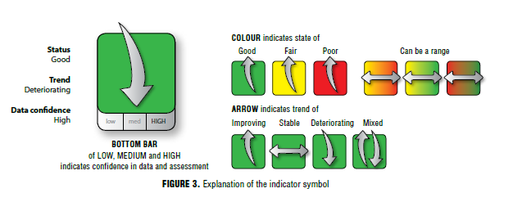
Figure 2. Overview of the indicator symbols.

Table 2. Guide to interpreting the symbols.

 | Category | Description | How is it derived? | Symbol Example
State  (can be a range) | Good | The level to which the indicator meets or exceeds (good), is close to meeting (fair) or is well below (poor) a given standard for healthy ecosystems, habitats, species, airsheds, watersheds or an urban environment. | Assessment is based on 1) recent trends, 2) comparison with similar jurisdictions, and 3) comparison with ‘healthy’ habitats and systems. Where limited data exists to make an assessment based on these criteria, expert opinion is used. | 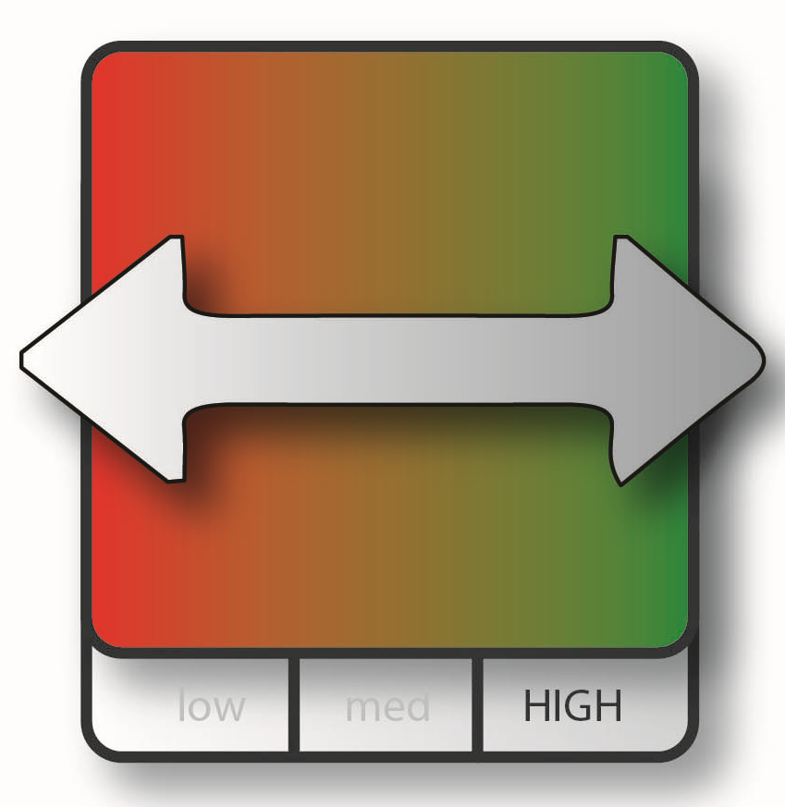
State  (can be a range) | Fair
State  (can be a range) | Poor
Trend | Improving | The state of the environment related to this indicator is getting better. | Trends show that indicators are improving. | 
Trend | Deteriorating | The state of the environment related to this indicator is getting worse. | Trends show a significant decrease, or based on weight of evidence that indicators are worsening. | 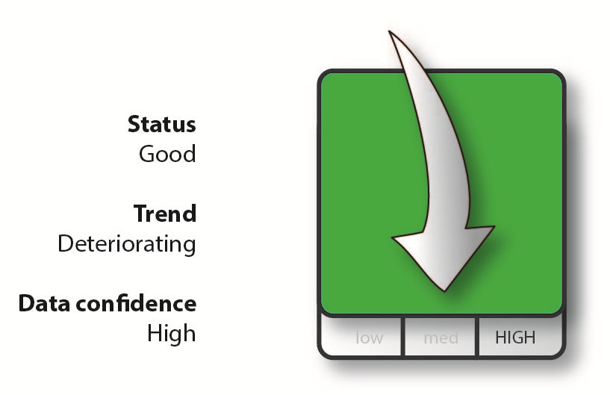
Trend | Stable | The state of the environment related to this indicator shows there is no detectable change. | Trends show no significant increase or decrease, or, based on weight of evidence that indicators are stable. | 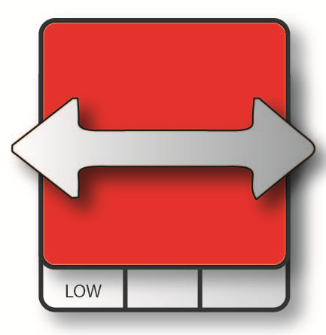
Trend | Mixed | The state of the environment related to this indicator shows a mixed trend: sometimes the state is getting better, worse, or there is no change. | Used primarily for sub-topics with multiple indicators, or in cases where data shows two distinct trends. | 
Trend | Undetermined | Not enough data exists to determine trend. | Insufficient data available to generate trend. | 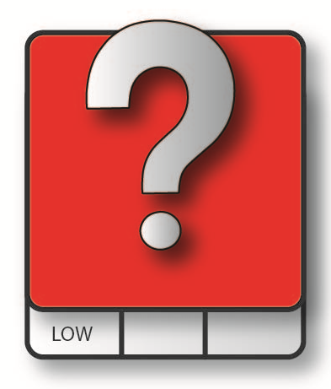
Confidence | High | Data is of high quality and provides good spatial and temporal representation. | Trusted and comprehensive time series and/or national level data sources are used to determine confidence trend. | 
Confidence | Medium | Data is either lower quality, geographically sparse or limited temporally. | Data is derived from many sources, and is not always consistent, with some extrapolation necessary.
Confidence | Low | Data does not meet any of the above criteria. | Data is very coarse and outdated, and limited to single country sites.
SUSTAINABLE DEVELOPMENT GOALS
The Sustainable Development Goals (SDGs), otherwise known as the Global Goals, are a universal call to action to end poverty, protect the planet and ensure that all people enjoy peace and prosperity. The SDGs provide clear guidelines and targets for all countries to adopt in accordance with their own priorities and the environmental challenges of the world at large. The goals are interconnected – often the key to success on one will involve tackling issues more commonly associated with another.

Throughout this report, the SDGs and their targets are linked to the different indicators using the symbols below (Figure 3).
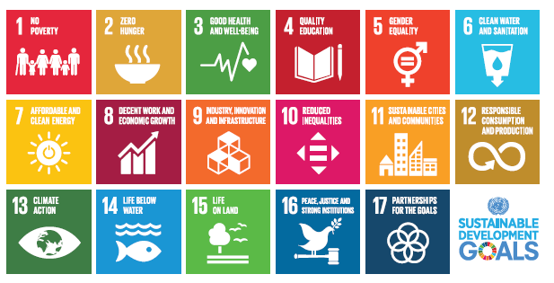
Figure 3. The Sustainable Development Goals (SDGs).

AICHI BIODIVERSITY TARGETS

The Strategic Plan for Biodiversity 2011–2020, under the Convention on Biological Diversity (CBD), con sists of five strategic goals, including 20 Aichi Biodiversity Targets (Table 3). The Aichi targets are linked to relevant indicators in this SoE using the symbols below.

Table 3. Overview of Aichi Biodiversity Targets.
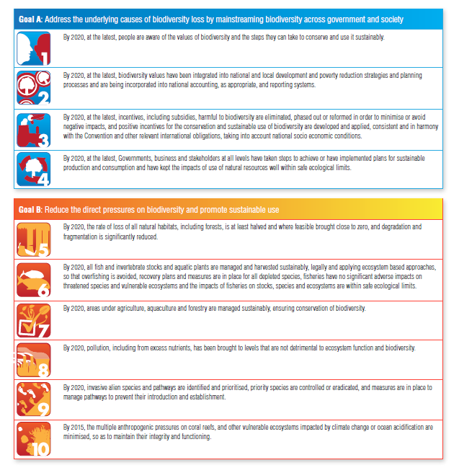
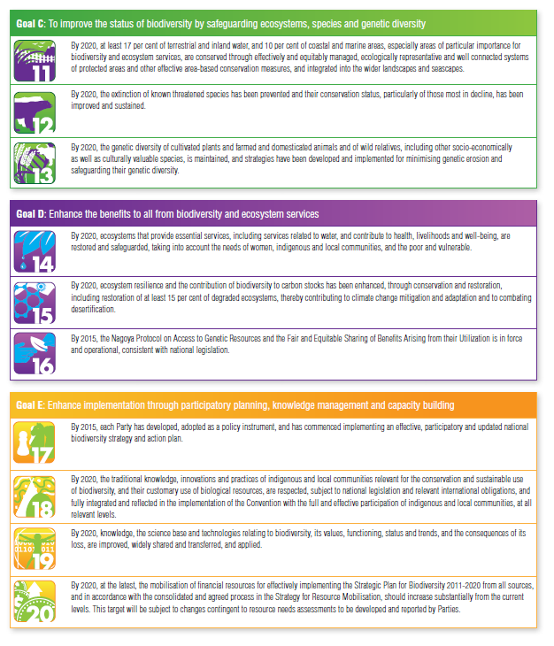
MAPPING INDICATORS TO AICHI TARGETS AND SDGs

Indicators in this SoE can be reused for other reporting obligations, including Aichi targets and SDGs, thus reducing the reporting burden on PICs. For each indicator the relevant Aichi targets and SDGs are mapped below in table 3. More specific details on relevant SDG targets are included at the start of each indicator in section 3.

Table 3. Core indicators mapped to Aichi targets and SDGs.

Indicator | CBD | SDG
GREENHOUSE GAS (GHG) EMISSIONS |  | 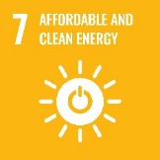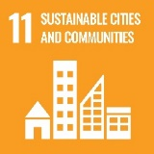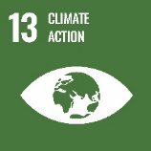
CONSUMPTION OF OZONE DEPLETING SUBSTANCES (ODS) |  | 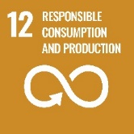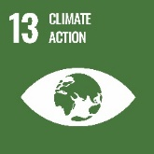
RENEWABLE ENERGY |  | 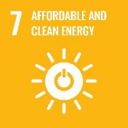
CLIMATE-RELATED DEATHS |  | 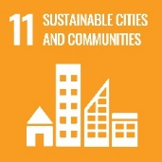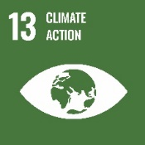
CLIMATE-RELATED DISASTER LOSSES |  | 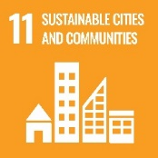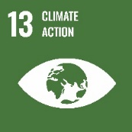
FUNDING FOR ECOYSTEM-BASED ADAPTATION |  | 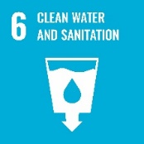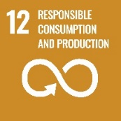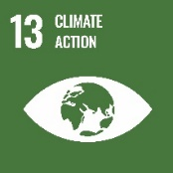  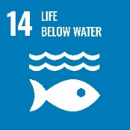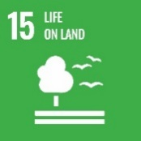
CLIMATE ADAPTATION AND MITIGATON FUNDING |  | 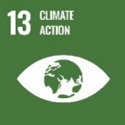
TERRESTRIAL PROTECTED AREAS |    | 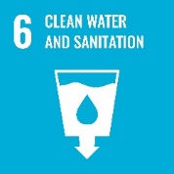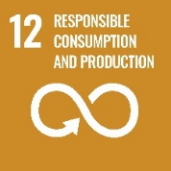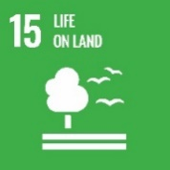
WETLANDS | 
INVASIVE SPECIES UNDER MANAGEMENT OR ERADICATED | 
PRIORITY SITES WITH INVASIVE SPECIES MANAGED | 
IUCN RED LIST SUMMARY |  | 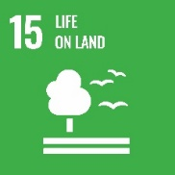
STATUS OF THREATENED, ENDEMIC AND MIGRATORY SPECIES |  | 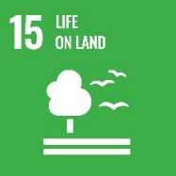
FRESHWATER QUALITY | 
HOUSEHOLD WASTE CAPTURED |  | 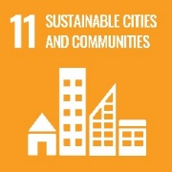  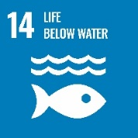
PER CAPITA GENERATION OF MUNICIPAL SOLID WASTE | 
HOUSEHOLD WASTE RECYCLED
ACCESS TO AND QUALITY OF SEWAGE TREATMENT | 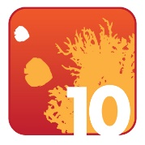
LIVE CORAL COVER |   
LAGOON WATER QUALITY
MARINE PROTECTED AREAS
COMMERCIAL PELAGIC FISHES
INSHORE FISH BIOMASS
ENVIRONMENT MINISTRY BUDGET ALLOCATION | 
APPROVED DEVELOPMENT PROPOSALS WITH CONDITIONS
ENVIRONMENTAL CASES PROSECUTED
NATIVE TREE COVER
LAND UNDER CULTIVATION |  | 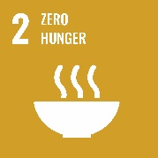

SECTION 2: DRIVERS AND PRESSURES ON THE COUNTRY ENVIRONMENT

Drivers for environmental change in COUNTRY
Human activities, such as urban development and overfishing, are placing pressures on the natural environments of the Pacific islands and their exclusive economic zones (EEZs). These activities are driven by broad social, economic, technological and cultural forces. These drivers interact to produce changes in the environment, which impact the livelihoods and well-being of individuals, communities and nations. The Year and Country SoE Report identifies five broad-level drivers of environmental change (Table 3).
Drivers can be changed to fit country and these are examples only.
- Population demographics and migration;
- Globalisation and geography;
- Economic and technological development;
- Traditional and contemporary values, attitudes, lifestyles and governance; and
- Climate change and variability.

DRIVER 1: POPULATION DEMOGRAPHICS AND MIGRATION

Example text and graphic, and content should be tailored to each country.

Population growth is a major driver of changes to the environment with pressures on both the built and natural environment. Figure 5 shows the historic, current and projected populations for the Pacific region from 1970 to 2050. Polynesia and Micronesia have lower historic and projected growth rates compared to Melanesia, in particular Papua New Guinea.

Add more figures and text relevant to country.

DRIVER 2: GEOGRAPHY AND GLOBILSATION

Specify driver and add figures and text relevant to country per Driver 1 example.

DRIVER 3: ECONOMIC AND TECHNOLOGICAL DEVELOPMENT

Specify driver and add figures and text relevant to country per Driver 1 example.

DRIVER 4: TRADITIONAL AND CONTEMPORARY VALUES, ATTITUDE AND LIFESTYLE

Specify driver and add figures and text relevant to country per Driver 1 example.

DRIVER 5: CLIMATE CHANGE

Specify driver and add figures and text relevant to country per Driver 1 example.

What environmental pressures are the drivers creating?
This section highlights the key pressures on the country’s environment and society created by the overarching drivers identified in the previous section. Pressure indicators present data about the main human activities that could adversely affect the environment. Pressure indicators are organised using three classifications: land development, resource extraction, and consumption and waste.

PRESSURE 1: LAND DEVELOPMENT
Pressure and text can be tailored to country.

PRESSURE 2: RESOURCE EXTRACTION
Pressure and text can be tailored to country.

PRESSURE 3: CONSUMPTION AND WASTE
Pressure and text can be tailored to country.

SECTION 3: STATE OF COUNTRY ENVIRONMENT, IMPACT AND RESPONSED

Theme 1: Atmosphere and climate
Add introduction to theme given country context
Theme | Indicators | Status and Trends | Response & Recommendations
ATMOSPHERE AND CLIMATE | Trend in Greenhouse Gas (GHG) emissions | Insert Status and Trend symbol | Insert key points from Response and Recommendations
ATMOSPHERE AND CLIMATE | Trend in consumption of ozone depleting substances (ODS) | Insert Status and Trend symbol | Insert key points from Response and Recommendations
ATMOSPHERE AND CLIMATE | Renewable energy | Insert Status and Trend symbol | Insert key points from Response and Recommendations
ATMOSPHERE AND CLIMATE | Climate-related deaths | Insert Status and Trend symbol | Insert key points from Response and Recommendations
ATMOSPHERE AND CLIMATE | Climate-related disaster losses | Insert Status and Trend symbol | Insert key points from Response and Recommendations
ATMOSPHERE AND CLIMATE | Funding for ecosystem management | Insert Status and Trend symbol | Insert key points from Response and Recommendations
ATMOSPHERE AND CLIMATE | Climate adaptation and mitigation funding | Insert Status and Trend symbol | Insert key points from Response and Recommendations

INDICATOR: GREENHOUSE GAS (GHG) EMISSIONS
CBD | SDG
 | 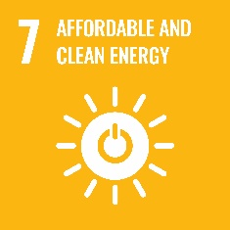 7.2  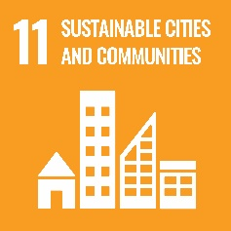 11.b  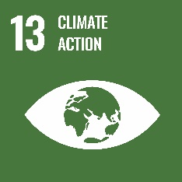 13.2

Definition
Trend of nationally determined contribution.
Status, trend and data confidence
Add relevant symbol based on interpretation of data.
Data presentation and discussion
Add graphs, tables and their captions/headings, as well as text interpreting these. Status, trend and data confidence must be based on these data.
Impacts
Add summary of the impacts of a poor state/deteriorating trend on people and the environment.
Response and recommendations
Add current responses from the government and recommendations for improving the state trend.
References
Add reference list for all in-text references for this indicator.

INDICATOR: CONSUMPTION OF OZONE DEPLETING SUBSTANCES (ODS)

CBD | SDG
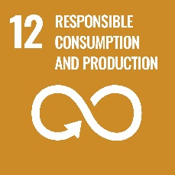 12.4
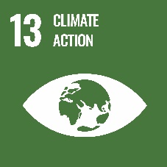 13.2

Definition
Trend in consumption of ozone depleting substances.
Status, trend and data confidence
Add relevant symbol based on interpretation of data.
Data presentation and discussion
Add graphs, tables and their captions/headings, as well as text interpreting these. Status, trend and data confidence must be based on these data.
Impacts
Add summary of the impacts of a poor state/deteriorating trend on people and the environment.
Response and recommendations
Add current responses from the government and recommendations for improving the state trend.
References
Add reference list for all in-text references for this indicator.

INDICATOR: RENEWABLE ENERGY
CBD | SDG
 | 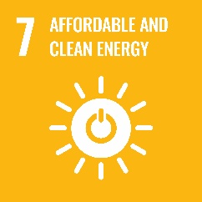 7.1, 7.2, 7.a, 7.b

Definition
Trend in % contribution of energy from renewable sources.
Status, trend and data confidence
Add relevant symbol based on interpretation of data.
Data presentation and discussion
Add graphs, tables and their captions/headings, as well as text interpreting these. Status, trend and data confidence must be based on these data.
Impacts
Add summary of the impacts of a poor state/deteriorating trend on people and the environment.
Response and recommendations
Add current responses from the government and recommendations for improving the state trend.
References
Add reference list for all in-text references for this indicator.

INDICATOR: CLIMATE-RELATED DEATHS
CBD | SDG
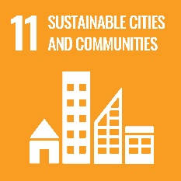 11.b
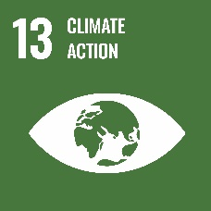 13.1

Definition
Annual number of climate-related deaths from declared disasters.
Status, trend and data confidence
Add relevant symbol based on interpretation of data.
Data presentation and discussion
Add graphs, tables and their captions/headings, as well as text interpreting these. Status, trend and data confidence must be based on these data.
Impacts
Add summary of the impacts of a poor state/deteriorating trend on people and the environment.
Response and recommendations
Add current responses from the government and recommendations for improving the state trend.
References
Add reference list for all in-text references for this indicator.

INDICATOR: CLIMATE-RELATED DEATHS
CBD | SDG
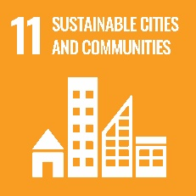 11.b
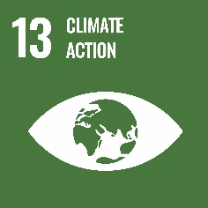 13.1

Definition
Annual number of climate-related deaths from declared disasters.
Status, trend and data confidence
Add relevant symbol based on interpretation of data.
Data presentation and discussion
Add graphs, tables and their captions/headings, as well as text interpreting these. Status, trend and data confidence must be based on these data.
Impacts
Add summary of the impacts of a poor state/deteriorating trend on people and the environment.
Response and recommendations
Add current responses from the government and recommendations for improving the state trend.
References
Add reference list for all in-text references for this indicator.

INDICATOR: CLIMATE-RELATED DISASTER LOSSES
CBD | SDG
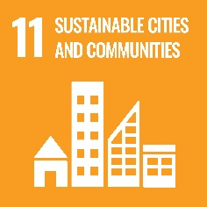 11.b
13.1

Definition
Annual total dollars of financial loss occurring due to climate-related disasters, defined as cyclones, flooding, landslides and drought.
Status, trend and data confidence
Add relevant symbol based on interpretation of data.
Data presentation and discussion
Add graphs, tables and their captions/headings, as well as text interpreting these. Status, trend and data confidence must be based on these data.
Impacts
Add summary of the impacts of a poor state/deteriorating trend on people and the environment.
Response and recommendations
Add current responses from the government and recommendations for improving the state trend.
References
Add reference list for all in-text references for this indicator.

INDICATOR: FUNDING FOR ECOYSTEM-BASED ADAPTATION
CBD | SDG
 | 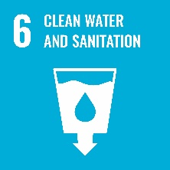 6.6  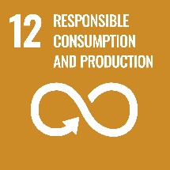 12.2  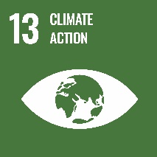 13.1  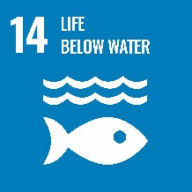 14.2, 14.5  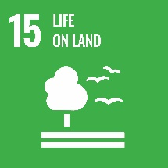 15.1

Definition
Annual total funds received to implement ecosystem-based approaches to climate adaptation.
Status, trend and data confidence
Add relevant symbol based on interpretation of data.
Data presentation and discussion
Add graphs, tables and their captions/headings, as well as text interpreting these. Status, trend and data confidence must be based on these data.
Impacts
Add summary of the impacts of a poor state/deteriorating trend on people and the environment.
Response and recommendations
Add current responses from the government and recommendations for improving the state trend.
References
Add reference list for all in-text references for this indicator.

INDICATOR: CLIMATE ADAPTATION AND MITIGATON FUNDING
CBD | SDG
 | 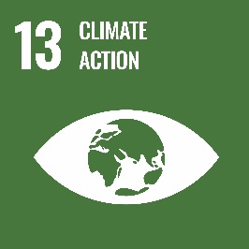 13.1

Definition
Annual total funds received for climate adaptation and mitigation projects.
Status, trend and data confidence
Add relevant symbol based on interpretation of data.
Data presentation and discussion
Add graphs, tables and their captions/headings, as well as text interpreting these. Status, trend and data confidence must be based on these data.
Impacts
Add summary of the impacts of a poor state/deteriorating trend on people and the environment.
Response and recommendations
Add current responses from the government and recommendations for improving the state trend.
References
Add reference list for all in-text references for this indicator.

Theme 2: Island and Ocean Ecosystems
Add introduction to theme given country context
Theme | Indicators | Status and Trends | Response & Recommendations
BIODIVERSITY | Terrestrial protected areas | Insert Status and Trend symbol | Insert key points from Response and Recommendations
BIODIVERSITY | Wetlands | Insert Status and Trend symbol | Insert key points from Response and Recommendations
BIODIVERSITY | Invasive species under management or eradicated | Insert Status and Trend symbol | Insert key points from Response and Recommendations
BIODIVERSITY | Priority sites with invasive species managed | Insert Status and Trend symbol | Insert key points from Response and Recommendations
BIODIVERSITY | IUCN red list summary | Insert Status and Trend symbol | Insert key points from Response and Recommendations
BIODIVERSITY | Status of threatened, endemic or migratory species | Insert Status and Trend symbol | Insert key points from Response and Recommendations
BIODIVERSITY | Freshwater quality | Insert Status and Trend symbol | Insert key points from Response and Recommendations

INDICATOR: TERRESTRIAL PROTECTED AREAS
CBD | SDG
     | 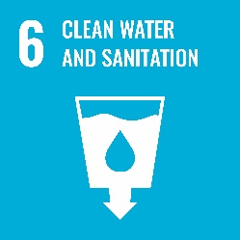 6.6  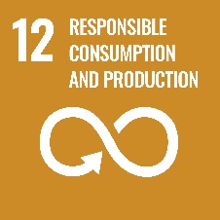 12.2  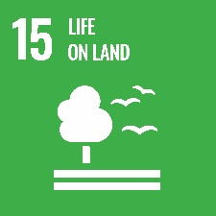 15.1, 15.2, 15.5

Definition
% of land area formally protected for conservation.
Status, trend and data confidence
Add relevant symbol based on interpretation of data.
Data presentation and discussion
Add graphs, tables and their captions/headings, as well as text interpreting these. Status, trend and data confidence must be based on these data.
Impacts
Add summary of the impacts of a poor state/deteriorating trend on people and the environment.
Response and recommendations
Add current responses from the government and recommendations for improving the state trend.
References
Add reference list for all in-text references for this indicator.

INDICATOR: WETLANDS
CBD | SDG
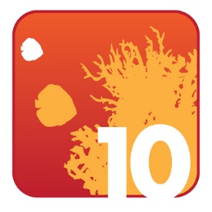 | 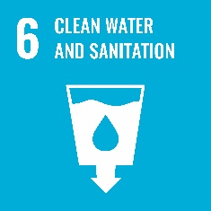 6.6  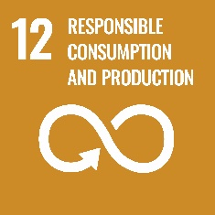 12.2  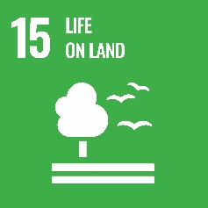 15.1, 15.2, 15.5

Definition
% cover of wetlands, mangroves and seagrass (note mangroves and seagrass could be separate indicators in the Coastal and Marine theme)
Status, trend and data confidence
Add relevant symbol based on interpretation of data.
Data presentation and discussion
Add graphs, tables and their captions/headings, as well as text interpreting these. Status, trend and data confidence must be based on these data.
Impacts
Add summary of the impacts of a poor state/deteriorating trend on people and the environment.
Response and recommendations
Add current responses from the government and recommendations for improving the state trend.
References
Add reference list for all in-text references for this indicator.

INDICATOR: INVASIVE SPECIES UNDER MANAGEMENT OR ERADICATED
CBD | SDG
   | 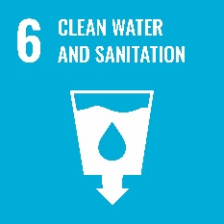 6.6  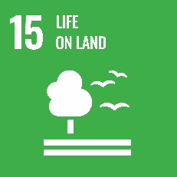 15.1, 15.5

Definition
% priority species under management or eradicated.
Status, trend and data confidence
Add relevant symbol based on interpretation of data.
Data presentation and discussion
Add graphs, tables and their captions/headings, as well as text interpreting these. Status, trend and data confidence must be based on these data.
Impacts
Add summary of the impacts of a poor state/deteriorating trend on people and the environment.
Response and recommendations
Add current responses from the government and recommendations for improving the state trend.
References
Add reference list for all in-text references for this indicator.

INDICATOR: PRIORITY SITES WITH INVASIVE SPECIES MANAGED
CBD | SDG
6.6
15.1, 15.5

Definition
Number of priority sites with multi-species invasive management programs
Status, trend and data confidence
Add relevant symbol based on interpretation of data.
Data presentation and discussion
Add graphs, tables and their captions/headings, as well as text interpreting these. Status, trend and data confidence must be based on these data.
Impacts
Add summary of the impacts of a poor state/deteriorating trend on people and the environment.
Response and recommendations
Add current responses from the government and recommendations for improving the state trend.
References
Add reference list for all in-text references for this indicator.

INDICATOR: IUCN RED LIST SUMMARY
CBD | SDG
 | 15.5

Definition
Number of species listed on the IUCN red list and summary of their threats.
Status, trend and data confidence
Add relevant symbol based on interpretation of data.
Data presentation and discussion
Add graphs, tables and their captions/headings, as well as text interpreting these. Status, trend and data confidence must be based on these data.
Impacts
Add summary of the impacts of a poor state/deteriorating trend on people and the environment.
Response and recommendations
Add current responses from the government and recommendations for improving the state trend.
References
Add reference list for all in-text references for this indicator.

INDICATOR: STATUS OF THREATENED, ENDEMIC AND MIGRATORY SPECIES
CBD | SDG
 | 15.5, 15.7, 15.c

Definition
Population trend of identified species.
Status, trend and data confidence
Add relevant symbol based on interpretation of data.
Data presentation and discussion
Add graphs, tables and their captions/headings, as well as text interpreting these. Status, trend and data confidence must be based on these data.
Impacts
Add summary of the impacts of a poor state/deteriorating trend on people and the environment.
Response and recommendations
Add current responses from the government and recommendations for improving the state trend.
References
Add reference list for all in-text references for this indicator.

INDICATOR: FRESHWATER QUALITY
CBD | SDG
   | 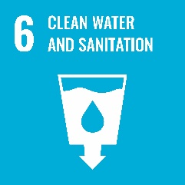 6.1, 6.3, 6.6  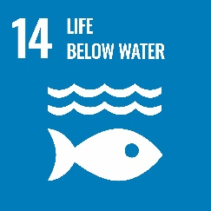 14.1

Definition
E. coli levels across freshwater monitoring sites.
Status, trend and data confidence
Add relevant symbol based on interpretation of data.
Data presentation and discussion
Add graphs, tables and their captions/headings, as well as text interpreting these. Status, trend and data confidence must be based on these data.
Impacts
Add summary of the impacts of a poor state/deteriorating trend on people and the environment.
Response and recommendations
Add current responses from the government and recommendations for improving the state trend.
References
Add reference list for all in-text references for this indicator.

Theme 3: Built environment
Add introduction to theme given country context

Theme | Indicators | Status and Trends | Response & Recommendations
BUILT ENVIRONMENT | Household waste captured | Insert Status and Trend symbol | Insert key points from Response and Recommendations
BUILT ENVIRONMENT | Per capita generation of municipal solid waste | Insert Status and Trend symbol | Insert key points from Response and Recommendations
BUILT ENVIRONMENT | Household waste recycled | Insert Status and Trend symbol | Insert key points from Response and Recommendations
BUILT ENVIRONMENT | Access to and quality of sewage treatment | Insert Status and Trend symbol | Insert key points from Response and Recommendations

INDICATOR: HOUSEHOLD WASTE CAPTURED
CBD | SDG
6.3
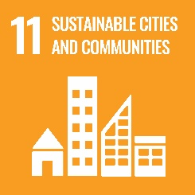 11.6
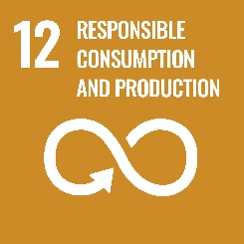 12.4
14.1

Definition
% household waste captured by authorised waste collection.
Status, trend and data confidence
Add relevant symbol based on interpretation of data.
Data presentation and discussion
Add graphs, tables and their captions/headings, as well as text interpreting these. Status, trend and data confidence must be based on these data.
Impacts
Add summary of the impacts of a poor state/deteriorating trend on people and the environment.
Response and recommendations
Add current responses from the government and recommendations for improving the state trend.
References
Add reference list for all in-text references for this indicator.

INDICATOR: PER CAPITA GENERATION OF MUNICIPAL SOLID WASTE
CBD | SDG
11.6
12.4

Definition
Annual per capita generation of municipal solid waste.
Status, trend and data confidence
Add relevant symbol based on interpretation of data.
Data presentation and discussion
Add graphs, tables and their captions/headings, as well as text interpreting these. Status, trend and data confidence must be based on these data.
Impacts
Add summary of the impacts of a poor state/deteriorating trend on people and the environment.
Response and recommendations
Add current responses from the government and recommendations for improving the state trend.
References
Add reference list for all in-text references for this indicator.

INDICATOR: HOUSEHOLD WASTE RECYCLED
CBD | SDG
11.6
12.4, 12.5

Definition
% of total household waste recycled.
Status, trend and data confidence
Add relevant symbol based on interpretation of data.
Data presentation and discussion
Add graphs, tables and their captions/headings, as well as text interpreting these. Status, trend and data confidence must be based on these data.
Impacts
Add summary of the impacts of a poor state/deteriorating trend on people and the environment.
Response and recommendations
Add current responses from the government and recommendations for improving the state trend.
References
Add reference list for all in-text references for this indicator.

INDICATOR: ACCESS TO AND QUALITY OF SEWAGE TREATMENT
CBD | SDG
6.2, 6.3
14.1

Definition
Population trend of identified species.
Status, trend and data confidence
Add relevant symbol based on interpretation of data.
Data presentation and discussion
Add graphs, tables and their captions/headings, as well as text interpreting these. Status, trend and data confidence must be based on these data.
Impacts
Add summary of the impacts of a poor state/deteriorating trend on people and the environment.
Response and recommendations
Add current responses from the government and recommendations for improving the state trend.
References
Add reference list for all in-text references for this indicator.

Theme 4: Coastal and marine
Add introduction to theme given country context

Theme | Indicators | Status and Trends | Response & Recommendations
COASTAL AND MARINE | Live coral cover | Insert Status and Trend symbol | Insert key points from Response and Recommendations
COASTAL AND MARINE | Lagoon water quality | Insert Status and Trend symbol | Insert key points from Response and Recommendations
COASTAL AND MARINE | Marine protected areas | Insert Status and Trend symbol | Insert key points from Response and Recommendations
COASTAL AND MARINE | Commercial pelagic fishes | Insert Status and Trend symbol | Insert key points from Response and Recommendations
COASTAL AND MARINE | Inshore fish biomass | Insert Status and Trend symbol | Insert key points from Response and Recommendations

INDICATOR: LIVE CORAL COVER
CBD | SDG
6.3
14.1, 14.2

Definition
% live coral cover across representative monitoring sites.
Status, trend and data confidence
Add relevant symbol based on interpretation of data.
Data presentation and discussion
Add graphs, tables and their captions/headings, as well as text interpreting these. Status, trend and data confidence must be based on these data.
Impacts
Add summary of the impacts of a poor state/deteriorating trend on people and the environment.
Response and recommendations
Add current responses from the government and recommendations for improving the state trend.
References
Add reference list for all in-text references for this indicator.

INDICATOR: LAGOON WATER QUALITY
CBD | SDG
6.3
14.1, 14.2

Definition
Entetococci levels across lagoon monitoring sites.
Status, trend and data confidence
Add relevant symbol based on interpretation of data.
Data presentation and discussion
Add graphs, tables and their captions/headings, as well as text interpreting these. Status, trend and data confidence must be based on these data.
Impacts
Add summary of the impacts of a poor state/deteriorating trend on people and the environment.
Response and recommendations
Add current responses from the government and recommendations for improving the state trend.
References
Add reference list for all in-text references for this indicator.

INDICATOR: MARINE PROTECTED AREAS
CBD | SDG
 | 14.2, 14.5

Definition
% of EEZ formally protected for conservation.
Status, trend and data confidence
Add relevant symbol based on interpretation of data.
Data presentation and discussion
Add graphs, tables and their captions/headings, as well as text interpreting these. Status, trend and data confidence must be based on these data.
Impacts
Add summary of the impacts of a poor state/deteriorating trend on people and the environment.
Response and recommendations
Add current responses from the government and recommendations for improving the state trend.
References
Add reference list for all in-text references for this indicator.

INDICATOR: COMMERCIAL PELAGIC FISHES
CBD | SDG
 | 14.4, 14.6, 14.7

Definition
Trend in biomass of tuna stocks.
Status, trend and data confidence
Add relevant symbol based on interpretation of data.
Data presentation and discussion
Add graphs, tables and their captions/headings, as well as text interpreting these. Status, trend and data confidence must be based on these data.
Impacts
Add summary of the impacts of a poor state/deteriorating trend on people and the environment.
Response and recommendations
Add current responses from the government and recommendations for improving the state trend.
References
Add reference list for all in-text references for this indicator.

INDICATOR: INSHORE FISH BIOMASS
CBD | SDG
 | 14.2, 14.4, 14.6, 14.7

Definition
Trends in biomass or size classes for inshore fish populations.
Status, trend and data confidence
Add relevant symbol based on interpretation of data.
Data presentation and discussion
Add graphs, tables and their captions/headings, as well as text interpreting these. Status, trend and data confidence must be based on these data.
Impacts
Add summary of the impacts of a poor state/deteriorating trend on people and the environment.
Response and recommendations
Add current responses from the government and recommendations for improving the state trend.
References
Add reference list for all in-text references for this indicator.

Theme 5: Culture and heritage
Add introduction to theme given country context

Theme | Indicators | Status and Trends | Response & Recommendations
CULTURE AND HERITAGE | Country to select indicators | Insert Status and Trend symbol | Insert key points from Response and Recommendations

INDICATOR: COUNTRY TO ADD THEIR OWN INDICATORS
CBD | SDG
Add any relevant CBD targets | Add any relevant SDG targets

Definition
Add relevant definition.
Status, trend and data confidence
Add relevant symbol based on interpretation of data.
Data presentation and discussion
Add graphs, tables and their captions/headings, as well as text interpreting these. Status, trend and data confidence must be based on these data.
Impacts
Add summary of the impacts of a poor state/deteriorating trend on people and the environment.
Response and recommendations
Add current responses from the government and recommendations for improving the state trend.
References
Add reference list for all in-text references for this indicator.

Theme 6: Environmental governance
Add introduction to theme given country context

Theme | Indicators | Status and Trends | Response & Recommendations
ENVIRONMENTAL GOVERNANCE | Environment Ministry budget allocation | Insert Status and Trend symbol | Insert key points from Response and Recommendations
ENVIRONMENTAL GOVERNANCE | MEA reporting requirements | Insert Status and Trend symbol | Insert key points from Response and Recommendations
ENVIRONMENTAL GOVERNANCE | Approved development proposals with conditions | Insert Status and Trend symbol | Insert key points from Response and Recommendations
ENVIRONMENTAL GOVERNANCE | Environmental cases prosecuted | Insert Status and Trend symbol | Insert key points from Response and Recommendations

INDICATOR: ENVIRONMENT MINISTRY BUDGET ALLOCATION
CBD | SDG



Definition
% national budget allocated to Environment Ministry for.
Status, trend and data confidence
Add relevant symbol based on interpretation of data.
Data presentation and discussion
Add graphs, tables and their captions/headings, as well as text interpreting these. Status, trend and data confidence must be based on these data.
Impacts
Add summary of the impacts of a poor state/deteriorating trend on people and the environment.
Response and recommendations
Add current responses from the government and recommendations for improving the state trend.
References
Add reference list for all in-text references for this indicator.

INDICATOR: MEA REPORTING REQUIREMENTS
CBD | SDG
NA | NA

Definition
% of MEA reporting requirements met on time.
Status, trend and data confidence
Add relevant symbol based on interpretation of data.
Data presentation and discussion
Add graphs, tables and their captions/headings, as well as text interpreting these. Status, trend and data confidence must be based on these data.
Impacts
Add summary of the impacts of a poor state/deteriorating trend on people and the environment.
Response and recommendations
Add current responses from the government and recommendations for improving the state trend.
References
Add reference list for all in-text references for this indicator.

INDICATOR: APPROVED DEVELOPMENT PROPOSALS WITH CONDITIONS
CBD | SDG
11.4, 11.
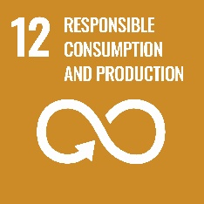 12.2, 12.b

Definition
% of approved development proposals with conditions imposed.
Status, trend and data confidence
Add relevant symbol based on interpretation of data.
Data presentation and discussion
Add graphs, tables and their captions/headings, as well as text interpreting these. Status, trend and data confidence must be based on these data.
Impacts
Add summary of the impacts of a poor state/deteriorating trend on people and the environment.
Response and recommendations
Add current responses from the government and recommendations for improving the state trend.
References
Add reference list for all in-text references for this indicator.

INDICATOR: ENVIRONMENTAL CASES PROSECUTED
CBD | SDG
11.4, 11.6
12.b

Definition
Number of environmental cases prosecuted.
Status, trend and data confidence
Add relevant symbol based on interpretation of data.
Data presentation and discussion
Add graphs, tables and their captions/headings, as well as text interpreting these. Status, trend and data confidence must be based on these data.
Impacts
Add summary of the impacts of a poor state/deteriorating trend on people and the environment.
Response and recommendations
Add current responses from the government and recommendations for improving the state trend.
References
Add reference list for all in-text references for this indicator.

Theme 7: Land
Add introduction to theme given country context

Theme | Indicators | Status and Trends | Response & Recommendations
LAND | Native tree cover | Insert Status and Trend symbol | Insert key points from Response and Recommendations
LAND | Land under cultivation | Insert Status and Trend symbol | Insert key points from Response and Recommendations

INDICATOR: NATIVE TREE COVER
CBD | SDG
 | 15.1, 15.2

Definition
% of total land area that is native tree cover.
Status, trend and data confidence
Add relevant symbol based on interpretation of data.
Data presentation and discussion
Add graphs, tables and their captions/headings, as well as text interpreting these. Status, trend and data confidence must be based on these data.
Impacts
Add summary of the impacts of a poor state/deteriorating trend on people and the environment.
Response and recommendations
Add current responses from the government and recommendations for improving the state trend.
References
Add reference list for all in-text references for this indicator.

INDICATOR: LAND UNDER CULTIVATION
CBD | SDG
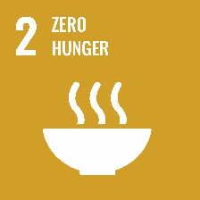 2.4
15.2

Definition
% of total land area that is under cultivation.
Status, trend and data confidence
Add relevant symbol based on interpretation of data.
Data presentation and discussion
Add graphs, tables and their captions/headings, as well as text interpreting these. Status, trend and data confidence must be based on these data.
Impacts
Add summary of the impacts of a poor state/deteriorating trend on people and the environment.
Response and recommendations
Add current responses from the government and recommendations for improving the state trend.
References
Add reference list for all in-text references for this indicator.

